Data Flow Diagram
Date
Team ID | xxxxxx
Project Name | EduGenie: Google Gemini Powered Learning Assistant
Maximum Marks | 2 Marks

Data Flow Diagram
The Data Flow Diagram (DFD) below shows how data moves through EduGenie - between external entities, processes and data stores.
DFD Symbol Legend
Symbol | Name | Description (in EduGenie)
Oval / Rounded shape | External Entity | Student / Learner, Google Gemini API, LaMini-Flan-T5 local model
Rectangle with numbered header | Process | 1 Request Handling, 2 AI Generation, 3 Explanation, 4 Response Formatting
Rectangle (solid fill, no number) | Data Store | .env configuration (API key, model name, explanation backend). EduGenie stores no user data.
Labeled arrow | Data Flow | Question / topic / text, prompts, generated text, JSON responses

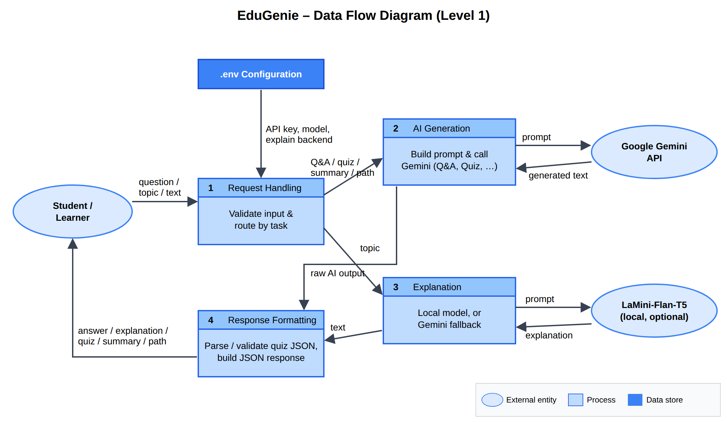
Figure: EduGenie Data Flow Diagram (Level 1)
Process Description
Process | Input | Output | Description
1. Request Handling | Question, topic or passage from the student | Validated request routed to the right module | FastAPI endpoints (/qa, /explain, /quiz, /summarize, /learn/recommendations) check for empty / too-long input (HTTP 400).
2. AI Generation | Validated text + feature-specific prompt | Raw Gemini text / JSON | gemini_client.py sends the prompt to Google Gemini (gemini-flash-latest) using the API key from .env.
3. Explanation | Topic | Simple explanation | Uses the local LaMini-Flan-T5-783M model when installed, otherwise (or on error) falls back to Gemini.
4. Response Formatting | Raw AI output | JSON response for the browser | Cleans Markdown code fences, validates quiz JSON (4 options, answer in options) and maps errors to 502/503.

